- Install MySQL Community Server or use an online SQL editor like db-fiddle.com, then create a new database named insta_clone_practice.
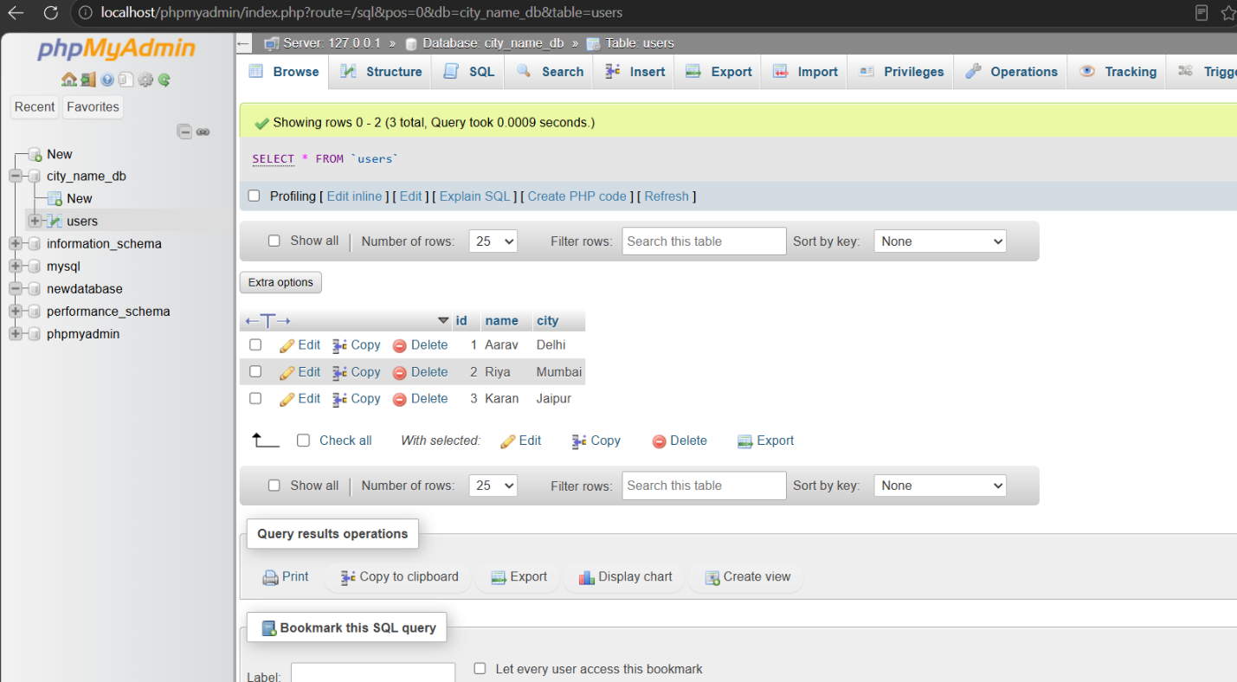
Ans:

- Inside your insta_clone_practice database, create a table called users with columns: id (INT, primary key, auto-increment), username (VARCHAR), email (VARCHAR), and created_at (DATETIME).
Ans:
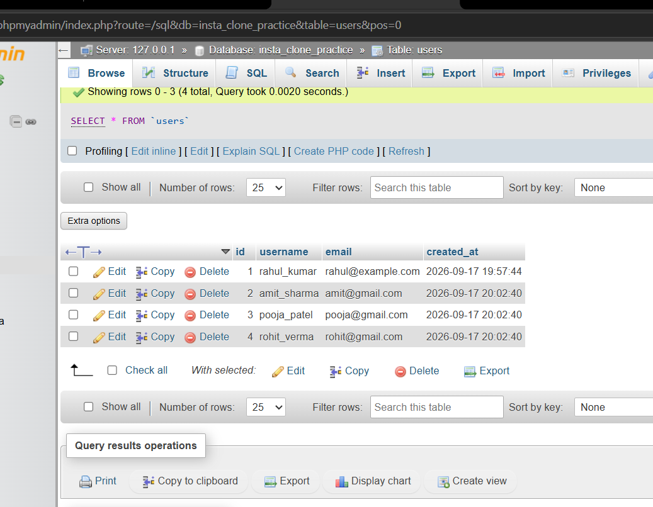

3. Insert 3 sample users into the users table with different usernames and emails, using SQL INSERT statements.
Ans:
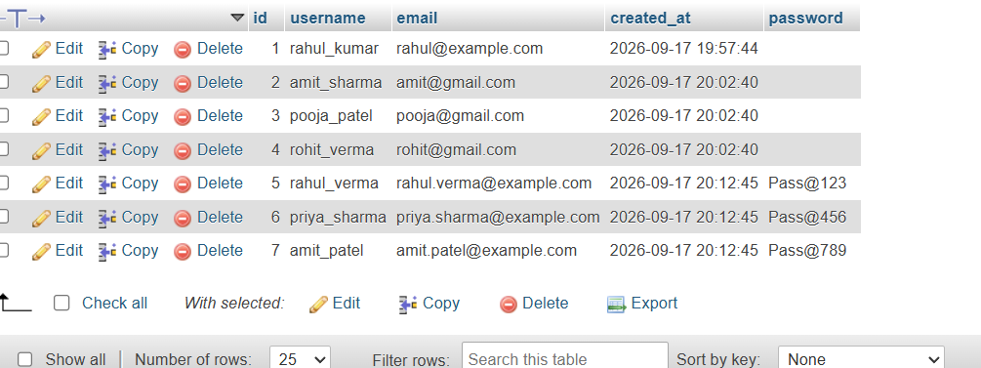

- Write a SQL SELECT query to fetch all users whose email ends with 'gmail.com' from the users table.Use the LIKE operator with a wildcard.
Ans:
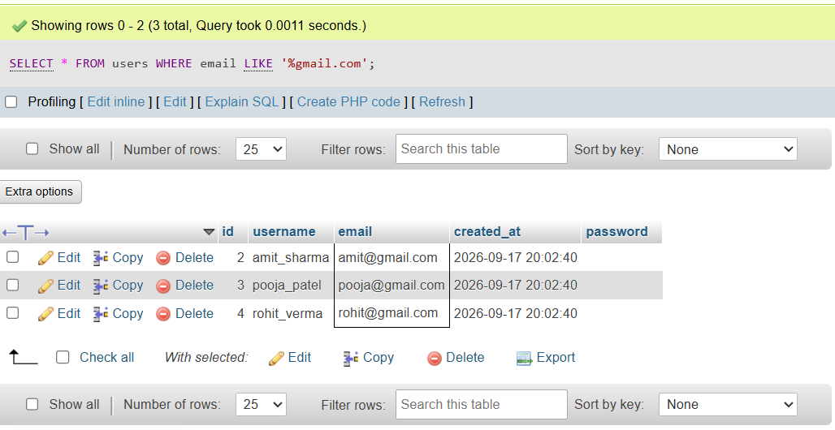

5. Create a comparison table (in any text editor) listing 3 differences between RDBMS (like MySQL) and NoSQL databases (like MongoDB), using real-world examples from apps like Instagram or WhatsApp.
Ans:
Feature | RDBMS (MySQL) | NoSQL (MongoDB)
Data Structure | Tables with fixed rows and columns (Structured Data). | JSON-like flexible documents or Key-Value pairs (Unstructured / Semi-structured).
Scaling Strategy | Vertical Scaling (Requires increasing server hardware resources like RAM and CPU). | Horizontal Scaling (Easy to scale out by adding more servers to a cluster).
Real-World App Example | Instagram User Accounts & Payments: Handles structured data like User Profile details and Subscriptions where strict ACID compliance is required. | WhatsApp Chat Messages & Insta Feeds: Handles massive volumes of unstructured, rapid real-time data like chat logs, media posts, and comments.

